

Foreign Medical Program Claim Cover Sheet  
Form 10-7959f-2

(Debut Date) Month xx, 2024 |

Version 1

Revision History

| Date | Version | Description | Author |
| --- | --- | --- | --- |
| XX/XX/XXXX | 1 | Product Debut | XXX |
| XX/XX/XXXX | 2 | XXX (what changes/updates/additions) | XXX |

Table of Contents

**Overview 4**

**Signed/in/signed out states 7**

**Introduction 8**

**Step 1: Veteran Information 9**

**Step 2: Identification information 10**

**Step 3: Mailing address 11**

**Step 4: Home address 12**

**Step 5: Contact information 14**

**Step 6: Review and submit 15**

**Error messages 20**

## Overview

VA.gov users can register for the Foreign Medical Program (FMP) program by filling out the online form (VA form 10-7959f-1). The Foreign Medical Program covers care received outside the US for a service-connected condition. Users can log in or can access and fill out the form without signing in.

The form can be accessed directly through this URL: <https://www.va.gov/health-care/foreign-medical-program/file-claim-form-10-7959f-2>

It can also be found on the health care home page: <https://www.va.gov/health-care/>

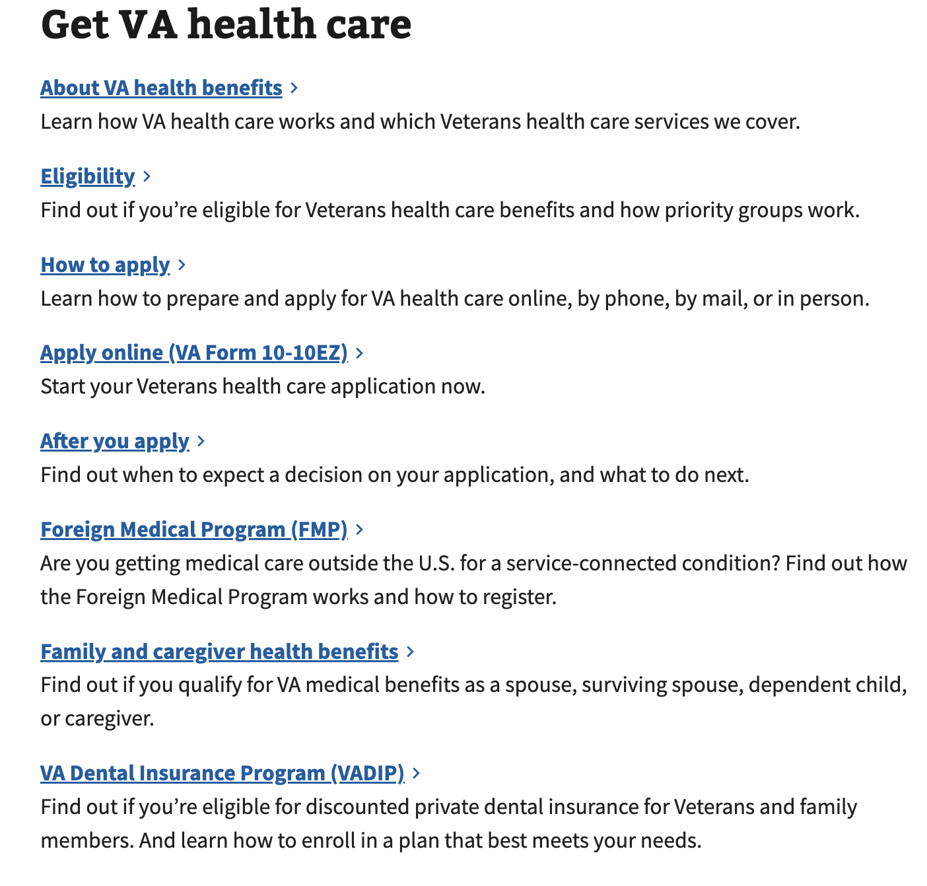

Navigating from the FMP link on the health care home page leads to the Foreign Medical Program page.

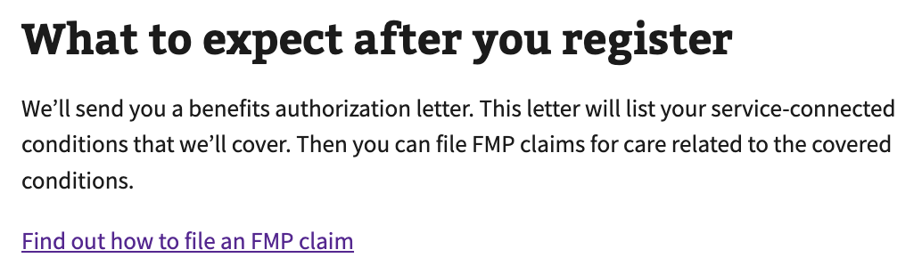

Steps for this form:

1. Personal information
2. Identification information
3. Mailing address
4. Home address
5. Contact information
6. Payment selection
7. Supporting files
8. Review and sign

## Signed/in/signed out states

* Signed out users can access the registration form through the introduction page. If they follow the unauthorized flow and are not signed into their VA.gov profile, they will not be able to save their progress if they leave the form before submitting.
* If the user signs in, they will be taken to the sign in screen and then able to save their progress when filling out the form.

## Introduction

To start your form, click the call to action on the introduction page:

## Step 1: Personal Information

The user is prompted to enter their name and DOB, which are required fields with the exception of middle initial and suffix.

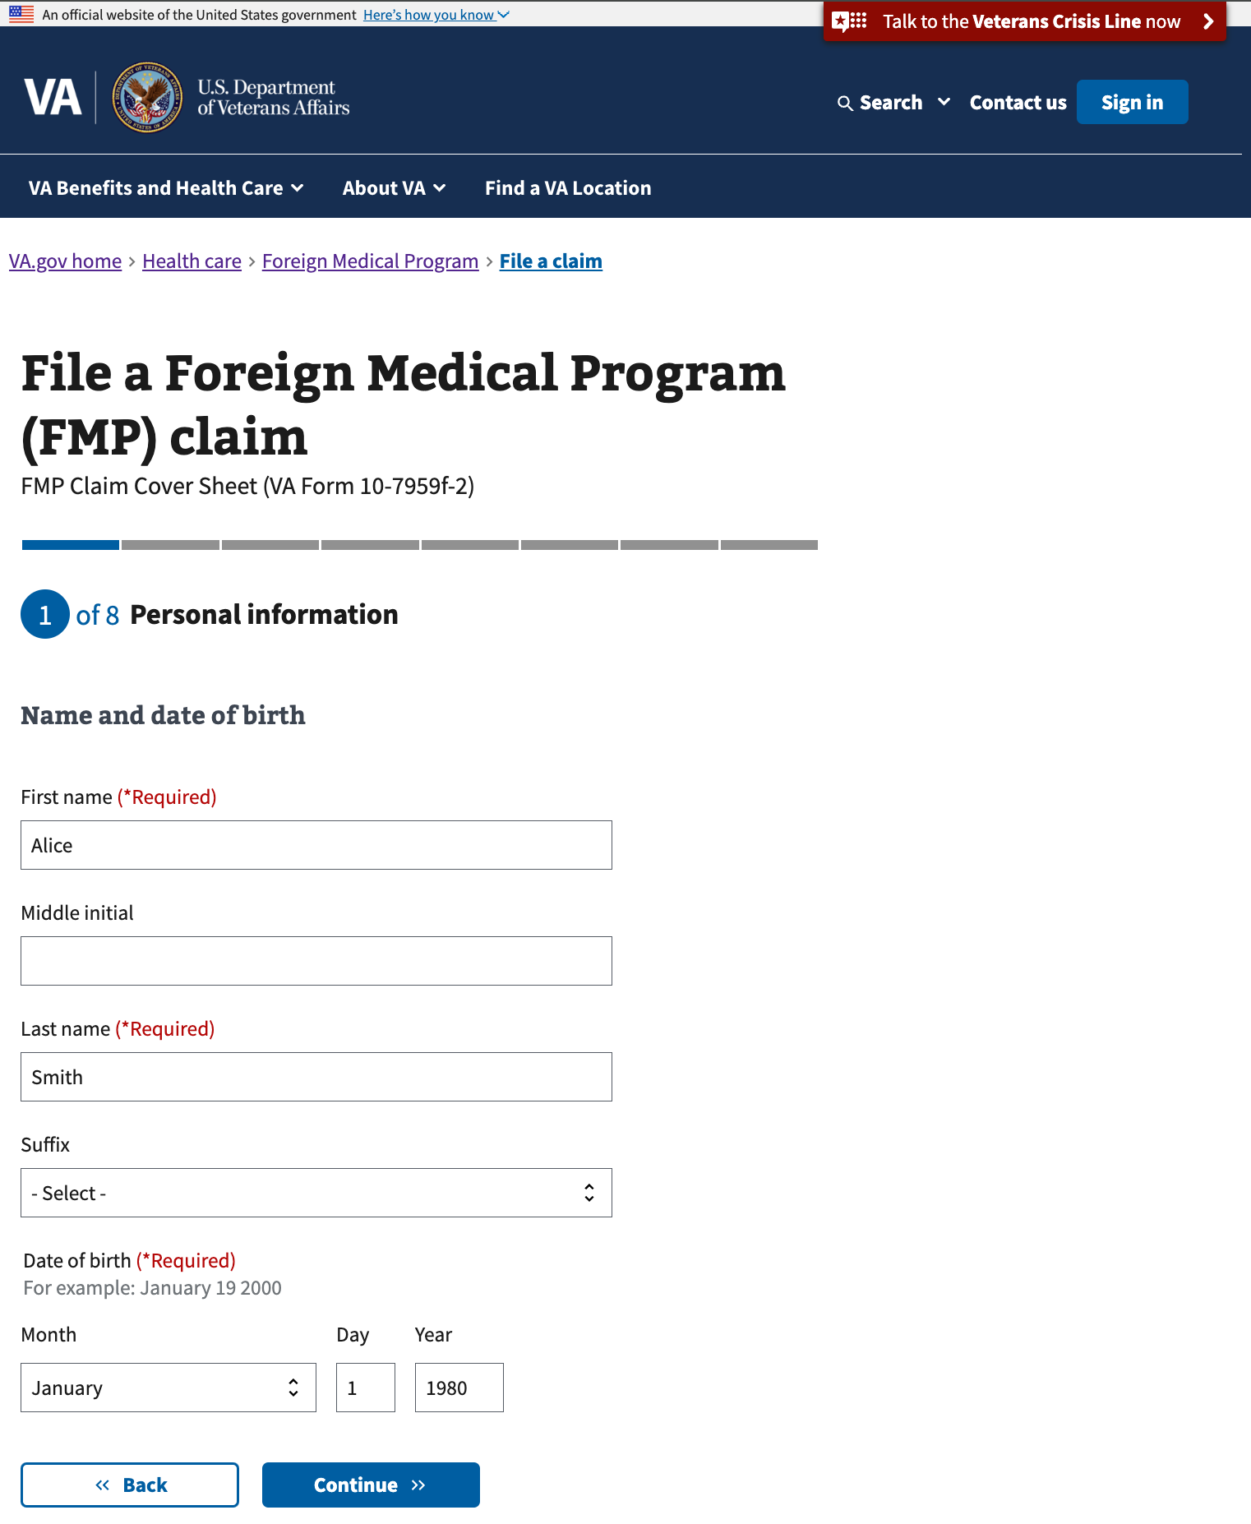

## Step 2: Identification information

The user must enter their SSN or VA file number (one or the other is required in order to proceed). If they enter more or less than the required number of digits, they will see an error message.

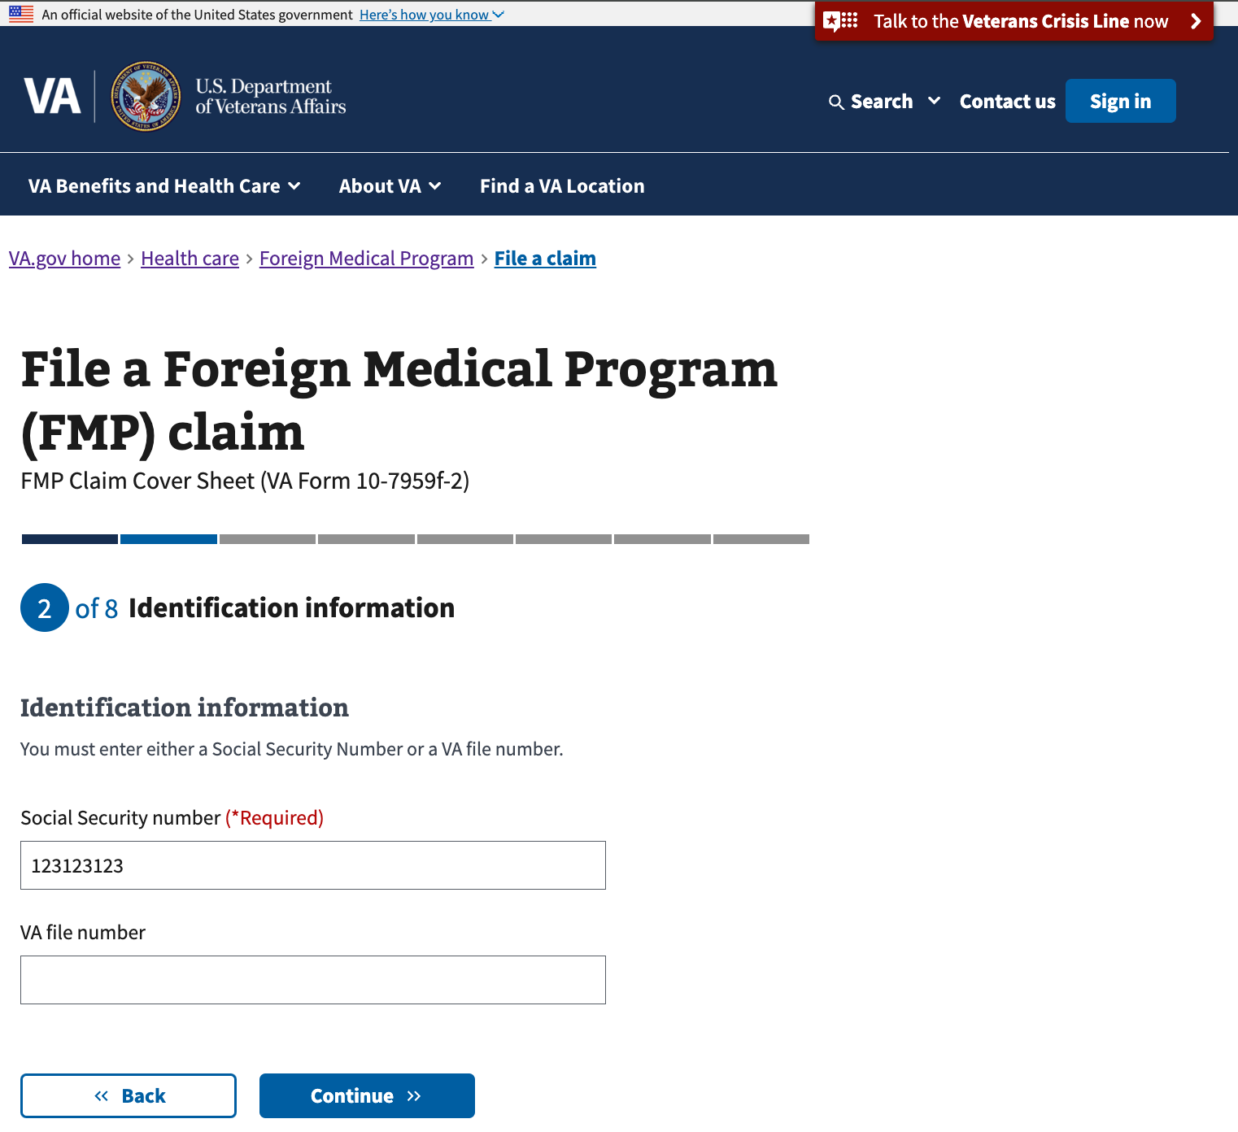

## Step 3: Mailing address

The user must enter a mailing address, which is where they will receive information in the mail regarding their submission. If they are on a military base, they can select the checkbox and the form fields will update.

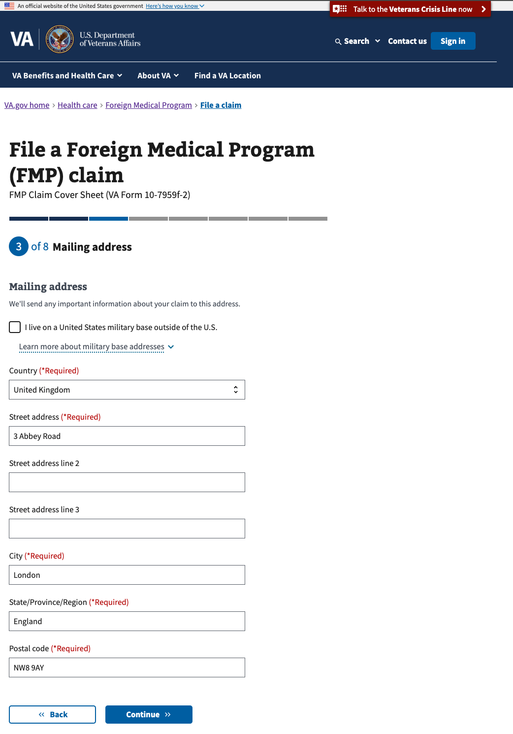

## Step 4: Home address

If the user’s mailing address is the same as their home address, they can indicate that on this screen by selecting yes, and they will continue to the next screen. If they select no, they will see the home address screen.

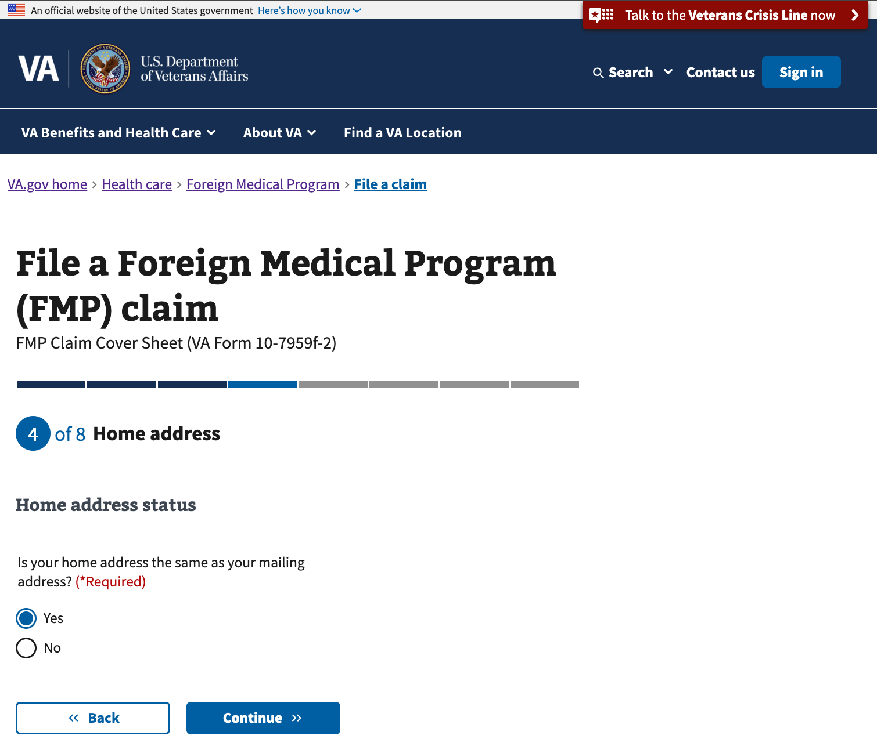

If the home address, or where they are physically located, is different from the mailing address, the user will be able to enter another address.

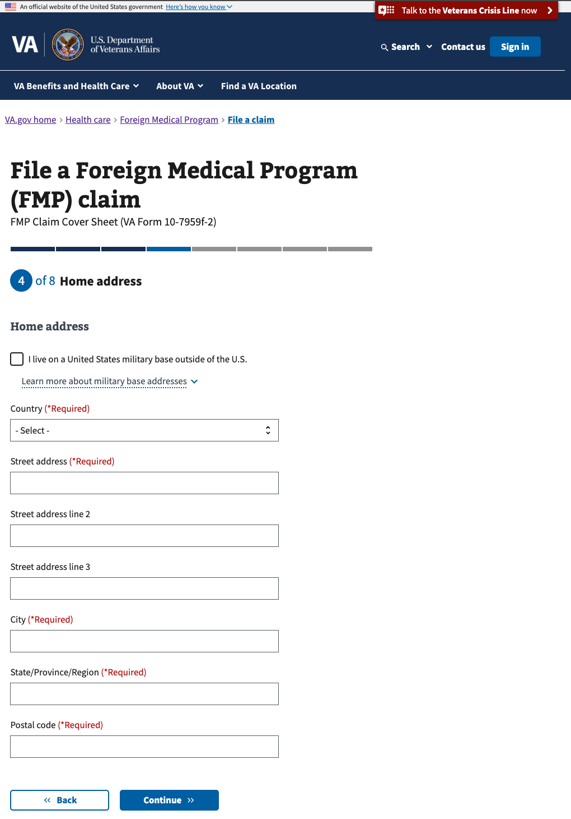

## Step 5: Contact information

The user must enter their phone number (they can include their country code if they have an international number) but adding an email address is optional. If they enter an email, they will be able to receive email confirmation upon submitting the form.

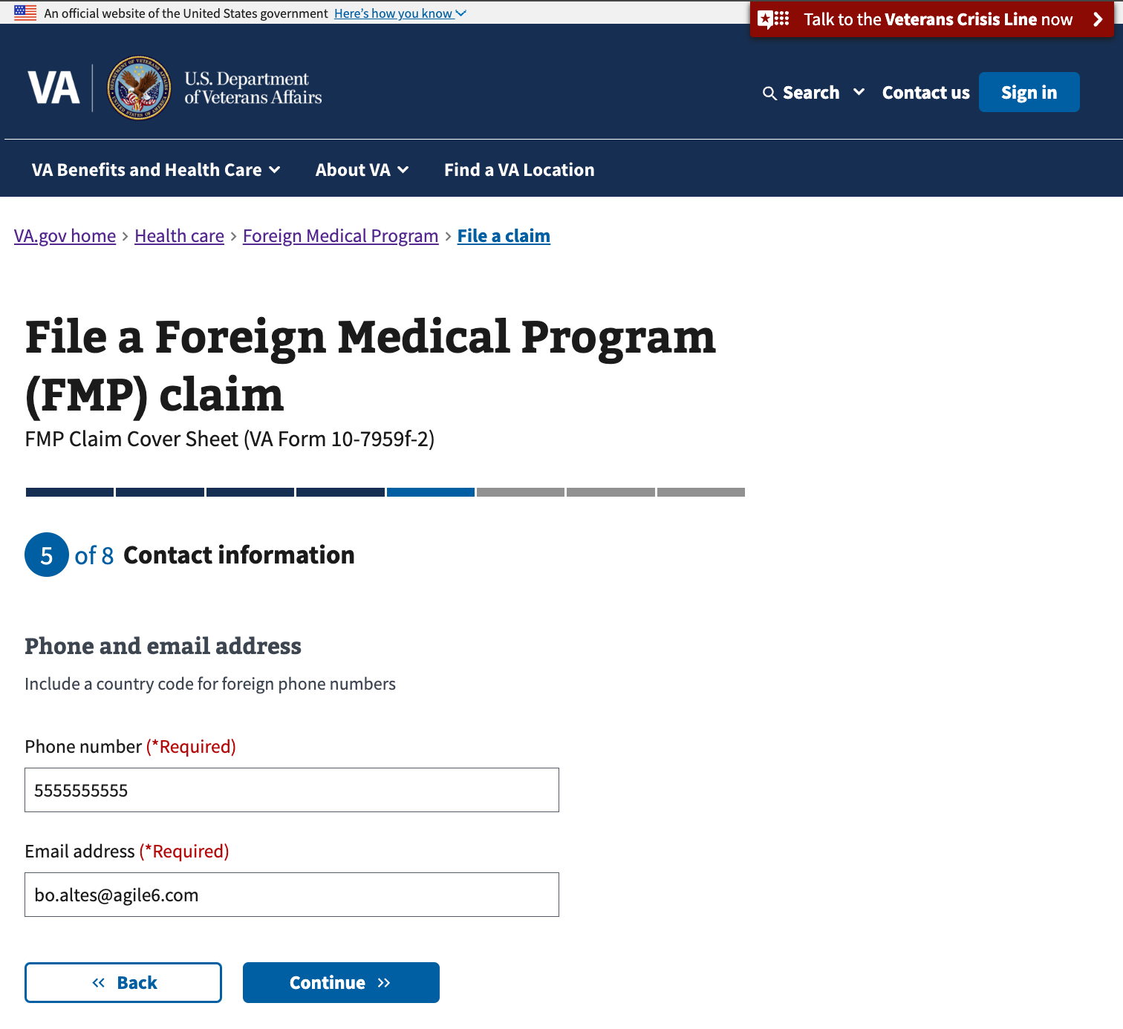

## Step 6: Payment selection

The user can choose to receive payment as a reimbursement, or to have payment sent to a provider.

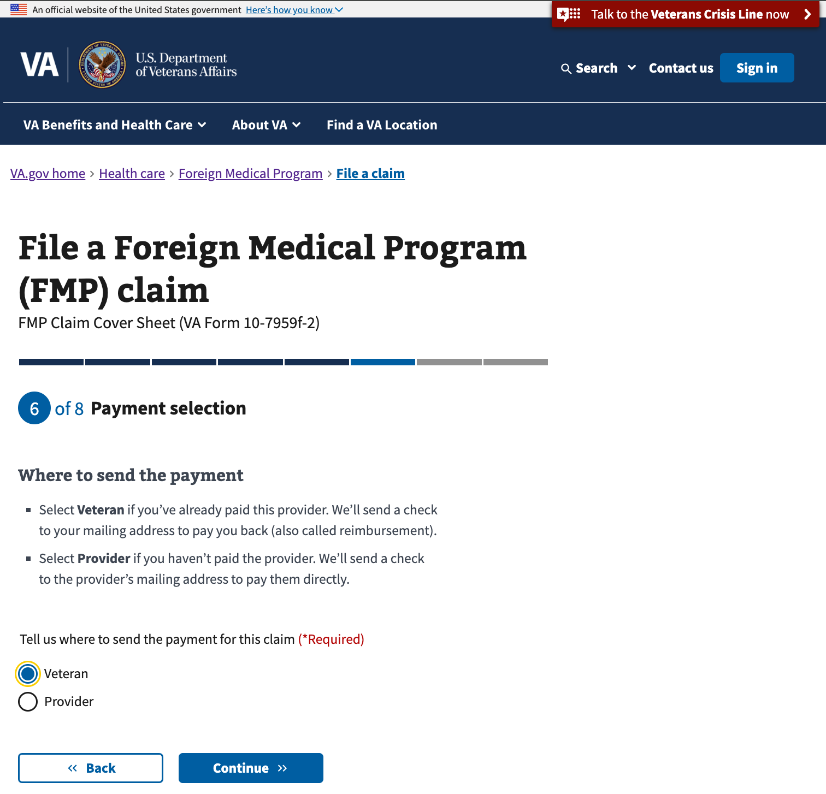

Based on this selection, the user will receive guidance on the supporting files they should provide on the next screen.

## Step 7: Supporting files

If the user is seeking reimbursement, they will receive the guidance below and can upload their supporting files.

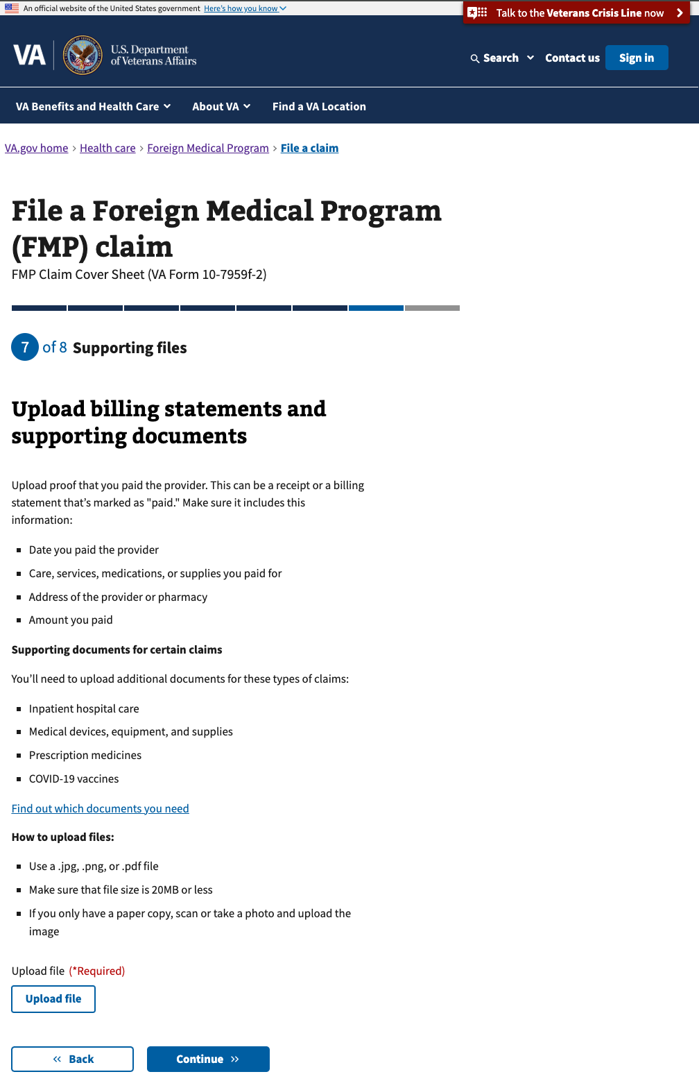

If the user indicates that payment should be sent to a provider, they will receive the guidance below and can upload their supporting files.

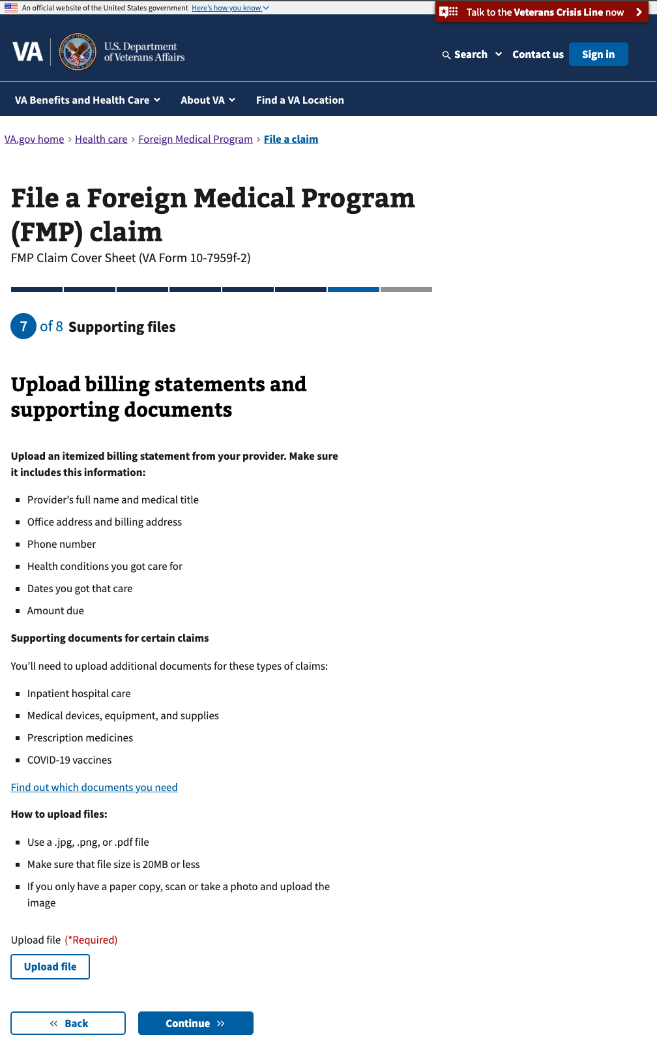

## Step 8: Review and submit

Before submitting their form, the user can review all the details of the information they entered in the previous screens. They can review each section by clicking on the plus sign to expand on the right side.

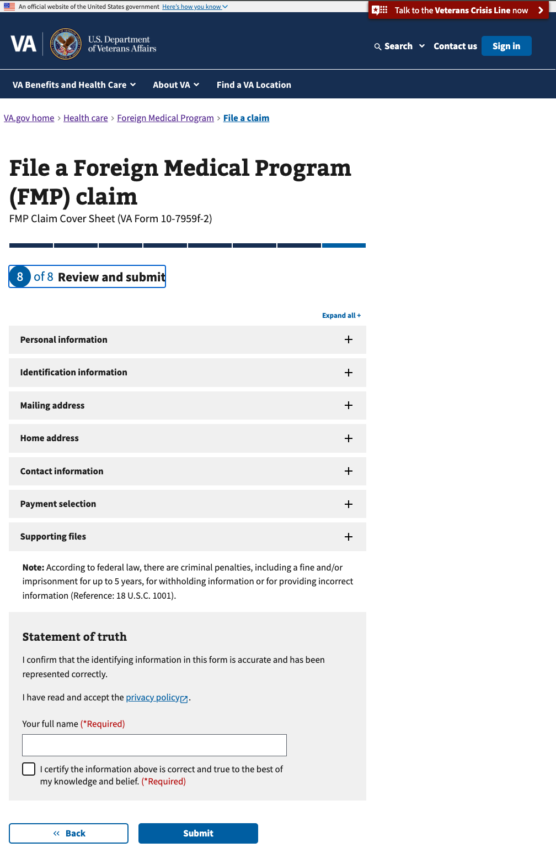

In the expanded view for each section, the user can edit their information directly in the form.

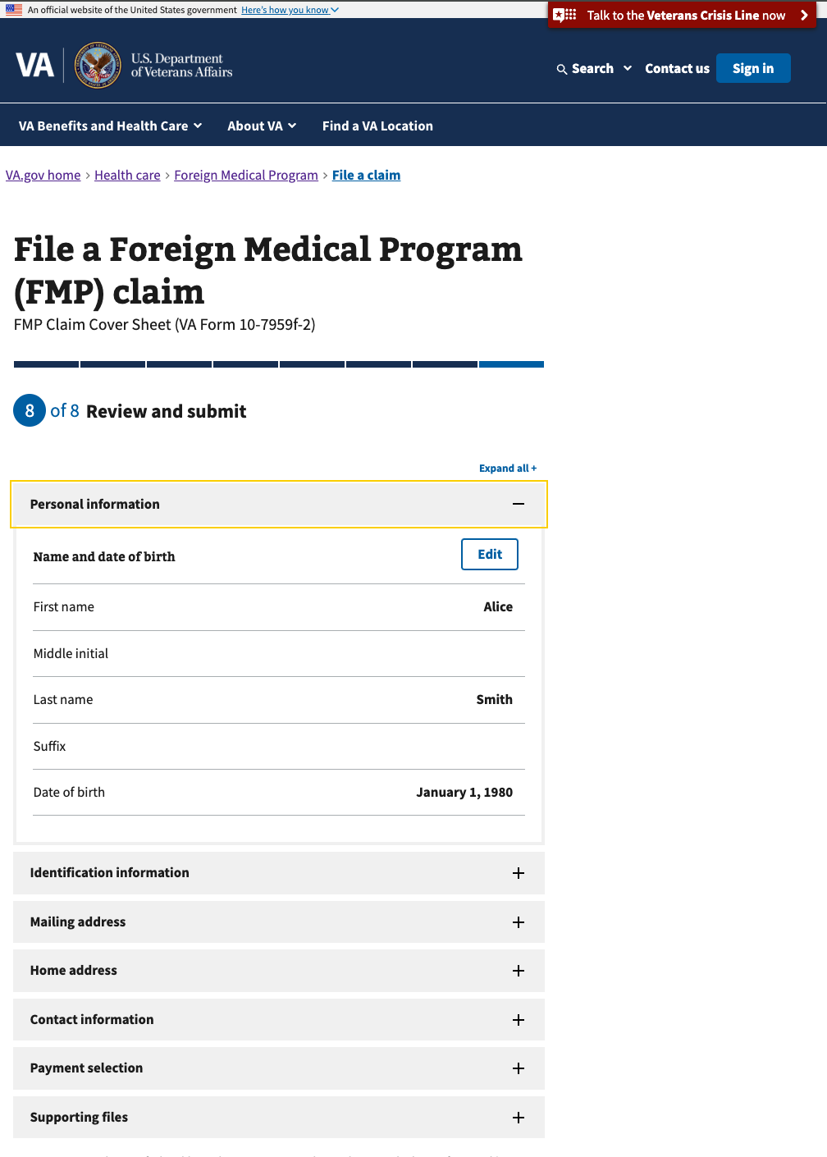

Saved progress

If the user is signed in, their progress is saved automatically, along with their responses. If they want to leave and finish the form later, they can exit by clicking on the ‘finish this application later’ link.

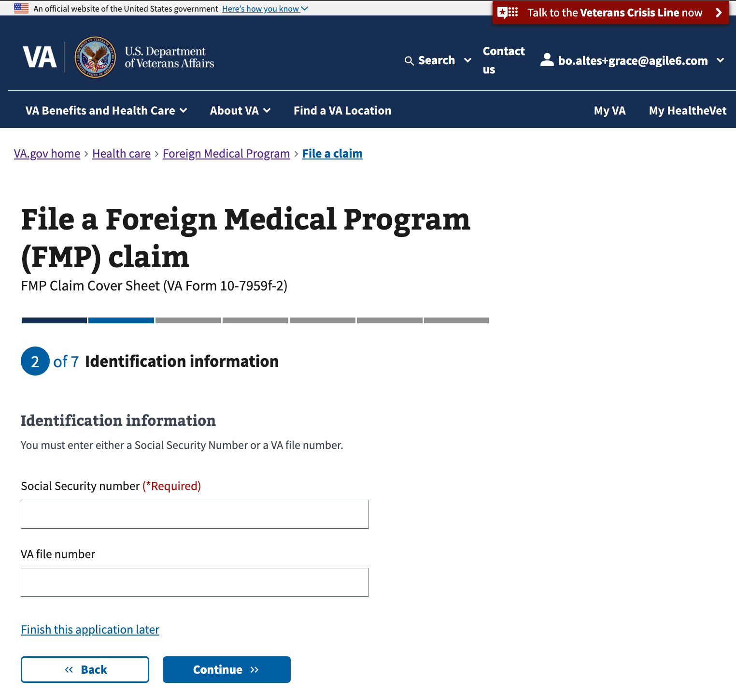

If the user is signed in, when they return to the form url, they should be able to continue the form where they left off and see their saved progress.

The user can also click to start a new application, which will clear out any previously entered responses and start the form from the beginning.

## Error messages

On the review page, if there is an issue submitting, the user will see this error message. (They will be able to try to submit again from this page).

For any connectivity issues during submission, this error message appears.

Required fields that are missing a response will appear outlined in red.

